October monthly report
Project Title:
Conversion of post-combustion gas from cement manufacturing to syngas by electrochemical CO₂ capture and reduction
……..........................................................
Dr. Pongkarn Chakthranont
Sothearoth Heng
NCR ID: 803198
Under the supervision of
Dr. Pongkarn Chakthranont
Contract Number: NCR-NN-2023-20170-EN
November 2024

- Tasks list for October
- Catalyst modification:
  - Fluorine-tuned NiSAC by using ultraflon PTFE as a fluorine source
  - Dual-atom single catalyst
  - Introducing PTFE and MWCNT additives
- Influence of Sustainion XC-2 ionomer loading on CO2RR performance of NiSAC under a diluted CO₂ at 200mA/cm²
- Long-term performance of NiSAC and PANI,PTFE@NiSAC under a pure CO₂ and 200mA/cm²
- Long-term performance of NiSAC under a pure CO₂ with 0.5M and 1M KOH anolyte at 100mA/cm²
- Experimental Procedure
Preparation of Ni0.5SAC@PANI and cathode electrode
Briefly, Ni0.5SAC (150mg) and PANI (75mg) were mixed in 15ml of IPA to make a dispersion solution. Subsequently, the dispersion solution was sonicated for 2h, followed by overnight stirring at a room temperature. Afterwards, the dispersed Ni0.5SAC@PANI was filtered out, followed by several washing with DI. The solid residue was then overnight dried at 80°C to finally obtain Ni0.5SAC@PANI powder. 150mg of Ni0.5SAC@PANI was added into a 10ml of IPA, followed by adding 381µL of XC-2 binder and sonicating for another hour to make an ink solution. The ink solution was then sprayed onto Sigracet 39BB carbon paper to obtain a mass loading of approx. 0.18 ± 0.1 mg/cm².

Synthesis of fluorine-tuned NiSAC (NiSAC@F):
Pyrolysis: Briefly, 0.5g of NiPc, 5g of Dicy, 5g of Urea, and an exact amount of Ultraflon (PTFE, 10-20% by NiPc weight) were homogeneously grinded. Afterwards, the homogeneous powder was transferred to a quartz boat and pyrolyzed at 800°C for 2h under 200ml/min Ar gas.
Physical Blend: PTFE (10-20% by catalyst weight) was directly added into a catalyst ink, followed by sonicating for 1h.

Synthesis of dual-atom single catalyst (NiFe-SAC)
0.5g of NiPc, 0.5g of FePc, 5g of Dicy, and 5g of Urea were homogeneously grinded. Afterwards, the homogeneous powder was transferred to a quartz boat and pyrolyzed at 800°C for 2h under 200ml/min Ar gas to obtain a Ni_{0.5}Fe_{0.5}SAC powder product.

Electrochemical CO2RR measurements
A 5 cm² MEA electrolyzer was used to evaluate the CO2RR performance under modulated operating conditions. The Ni foam, bipolar membrane (BPM), and different cathode catalysts were employed as the anode, membrane, and cathode electrode, respectively. 50 ml of 1M KOH was recirculated and used throughout the experiment as the anolyte at 8 ml/min. The humidified 15%CO₂/85%N₂ gas stream was introduced into the cathodic inlet under total flow rates of 100 ml/min. Meanwhile, the cathodic outlet was directly injected into an online gas-chromatography for gas products analysis.

- Results
CO2RR performance of Ni_{0.5}Fe_{0.5}SAC under a pure CO₂ at 200mA/cm⁻²

As shown in Fig. 1, the modified Ni_{0.5}Fe_{0.5}SAC exhibited lower FE(CO) than bare Ni0.5SAC under pure CO₂ at 200 mA/cm², indicating that introducing Fe into Ni0.5SAC favors HER over CO2RR activity. Based on this result, it is worth noting that the CO:H₂ ratio can be adjusted by modifying the Fe:Ni ratio.
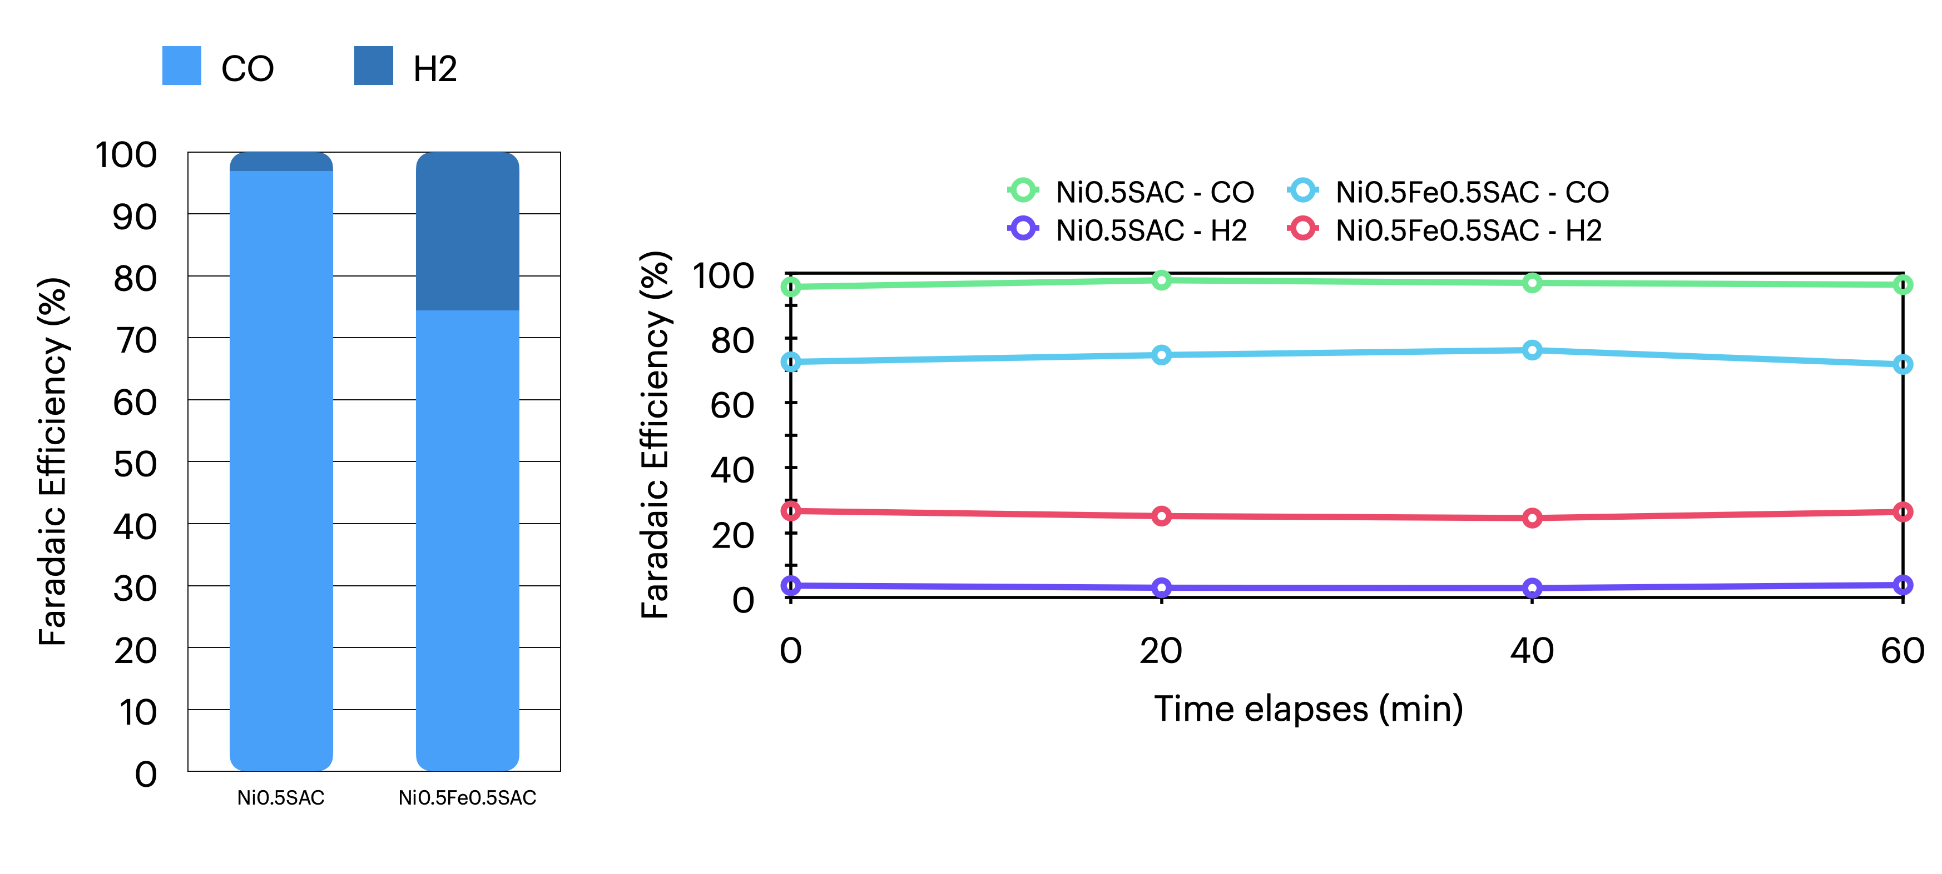
Figure 1. Faradaic efficiency of bare-Ni0.5SAC and Ni_{0.5}Fe_{0.5}SAC under a pure CO₂ condition at 200mA/cm²

Comparing CO2RR performance of NiSAC+PTFE and MWCNT with other additives under diluted 15%CO₂
Further studies on modifying the Ni0.5SAC catalyst were conducted by introducing Ultraflon PTFE and MWCNT to enhance its hydrophobicity. A comparis on of Ni0.5SAC with various modified versions is shown in Fig. 2. Pyr-Ni+PTFE and blend-Ni+PTFE exhibited similar performance to Ni0.5SAC, while blend-Ni+MWCNT demonstrated high HER activity, likely due to Ni active site blockage from MWCNT. In contrast, blend-Ni+PANI and blend-Ni+P showed excellent CO selectivity and stability, with FE(CO) >77% over a 3-hour operational period.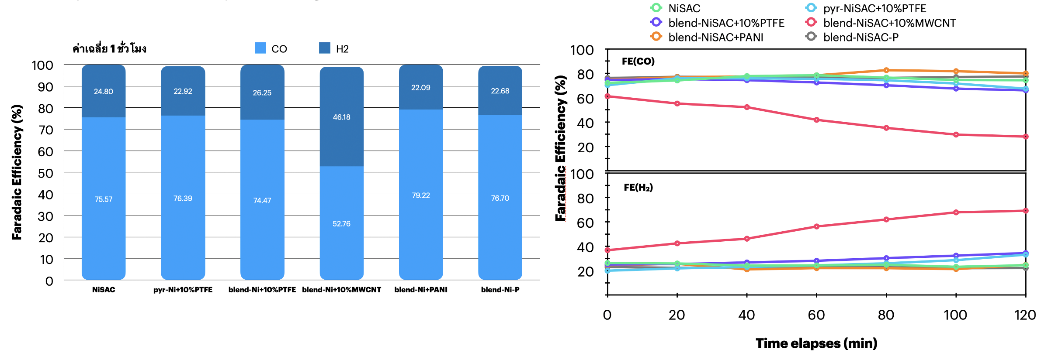
Figure 2. Faradaic efficiency of modified Ni0.5SAC with other additives under a diluted CO₂ condition at 200mA/cm²

Influence of Sustainion XC-2 ionomer loading on CO2RR performance of NiSAC under 15%CO₂ at 200mA/cm²
In the BPM system, designing the thickness of the anion exchange ionomer in the catalyst layer is crucial for improving local carbonate availability, CO₂ regeneration, and limiting K+ concentration at the catalyst/membrane interface. This ionomer has a positively charged backbone, which can significantly impact local ionic transport. As shown in Fig. 3, a Ni0.5SAC catalyst with 10% XC-2 loading achieved 76% FE(CO). However, increasing XC-2 ionomer loading to 20% and 30% may block Ni active sites, reducing CO₂ accessibility and CO selectivity. Additionally, higher ionomer loadings slightly increased the cell voltage.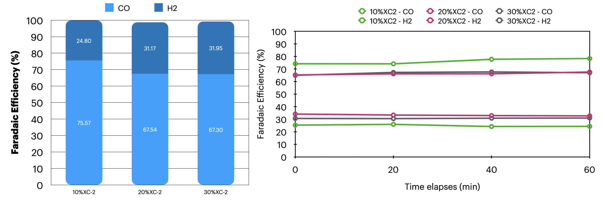
Figure 3. Faradaic efficiency of a Ni0.5SAC cathode with 10-30%wt XC-2 ionomer loadings under a diluted CO₂ condition at 200mA/cm²

Long-term CO₂ electrolysis of NiSAC and PANI,PTFE@NiSAC under a pure CO₂ at 200mA/cm²
Long-term CO₂ electrolysis of the BPM system with Ni0.5SAC and modified Ni0.5SAC with PANI and PTFE additives under pure CO₂ and 1M KOH at 200 mA/cm² is shown in Fig. 4. Both Ni0.5SAC and PANI@Ni0.5SAC maintained high CO selectivity, with FE(CO) >90% over 8 hours at 200 mA/cm². In contrast, FE(CO) for PTFE@Ni0.5SAC dropped significantly after 5 hours. Additionally, PTFE@Ni0.5SAC exhibited a substantially higher cell voltage compared to Ni0.5SAC and PANI@Ni0.5SAC, indicating reduced electrical conductivity in the presence of PTFE.
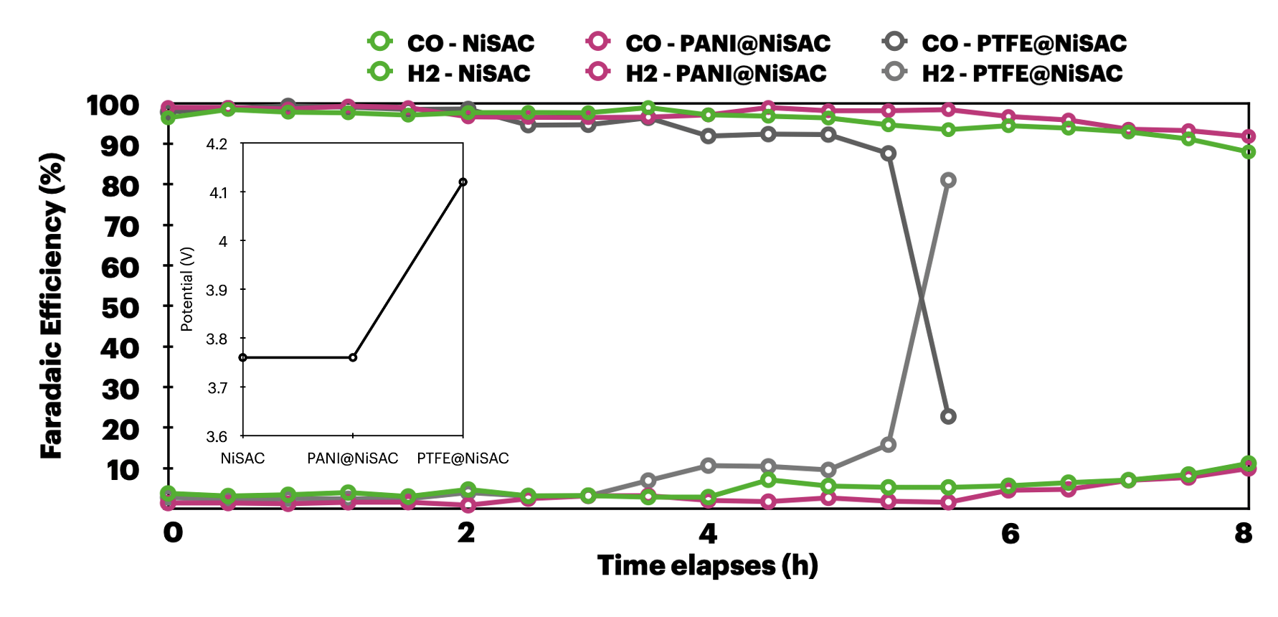
Figure 4. Long-term stability of Ni0.5SAC and PANI,PTFE@Ni0.5SAC under a pure CO₂ at 200mA/cm²

Long-term CO₂ electrolysis of NiSAC and PANI,PTFE@NiSAC under a pure CO₂ condition with 0.5M and 1.0M KOH anolyte at 100mA/cm²
To further mitigate K+ crossover, which could result in salt formation in the cathode region, the influence of KOH anolyte concentration on BPM system stability was tested under pure CO₂ with 0.5M and 1M KOH at 100 mA/cm². As shown in Fig. 5, a 1M KOH system exhibited a slightly lower cell voltage (3.32V) than the 0.5M system (3.49V). However, significant salt buildup occurred in the 1M KOH system after 13 hours, requiring frequent regeneration. After regeneration with DI water, the GDE became wetted, reducing hydrophobicity and causing HER activity over CO2RR. In contrast, the 0.5M KOH system maintained stability with FE(CO) >90% for over 40 hours, likely due to the lower K+ concentration, which reduced crossover and prevented severe salt formation. Salt formation began after 15 hours and required regeneration after 30 hours, as CO₂ output decreased significantly (from 150 to 70 ml/min over time). Frequent DI water regeneration can reduce GDE hydrophobicity, so alternative methods, such as pulse electrochemical regeneration or using a more diluted KOH concentration, may prolong cell lifespan.
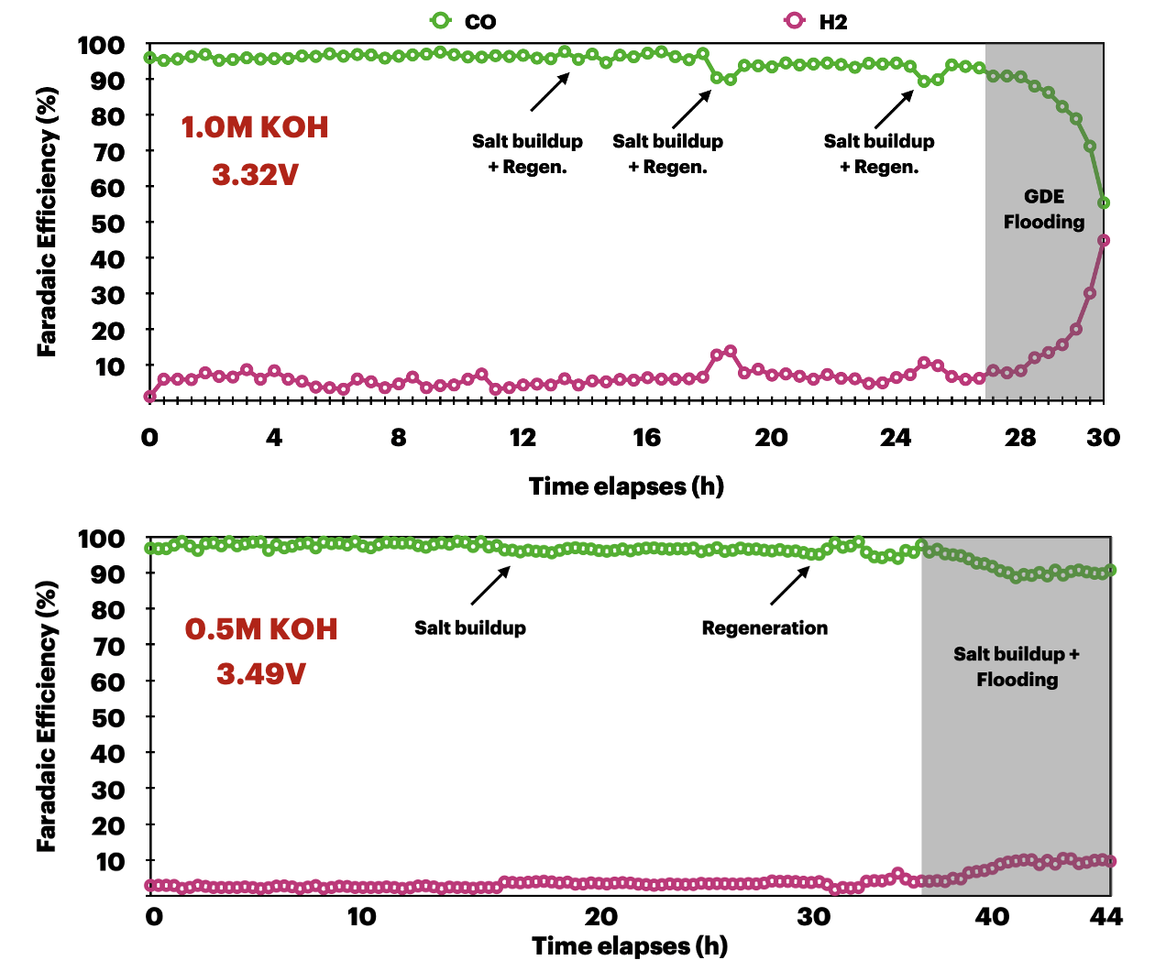
Figure 5. Long-term stability of Ni0.5SAC under a pure CO₂ with 0.5M and 1M KOH anolyte at 100mA/cm²

- Upcoming tasks
- Long-term stability:
  - under 0.1M KOH anolyte
  - pulse electrochemical method
- CO2RR of Ni0.5SAC with 5%XC-2 ionomer and PANI@Ni0.5SAC with higher Ni0.5SAC mass loading

